Experiment 05

Write a shell script and c program to perform the following string operation

1. To extract a sub string from a given string

Code:- STR =” WELCOME TO MIET”

Echo ${STR:3:5}

Output :-

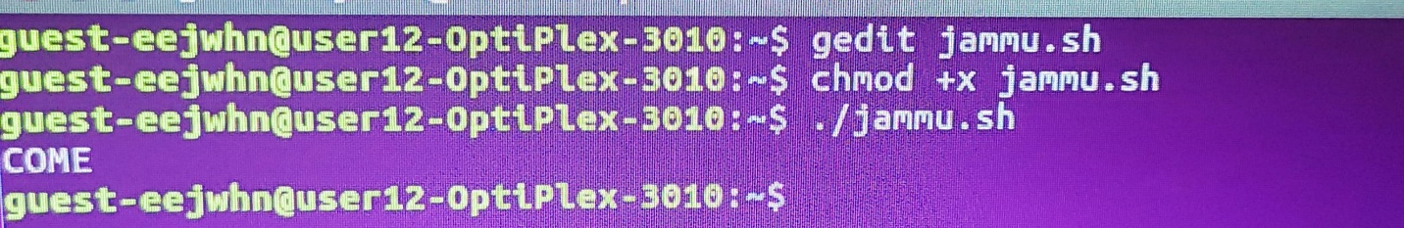

1. **To find the length of a given string**

**Code:- STR=”this is a string “**

**N=$(#str)**

**Echo “ Length of the string is : $n”**

**Output :-**

